**POSMD Accounts**

Dashboard

Change the label

“Total Slaughtered” to

“Total Number of Animals Slaughtered”

Reviewed: August 10, 2022(resolved)

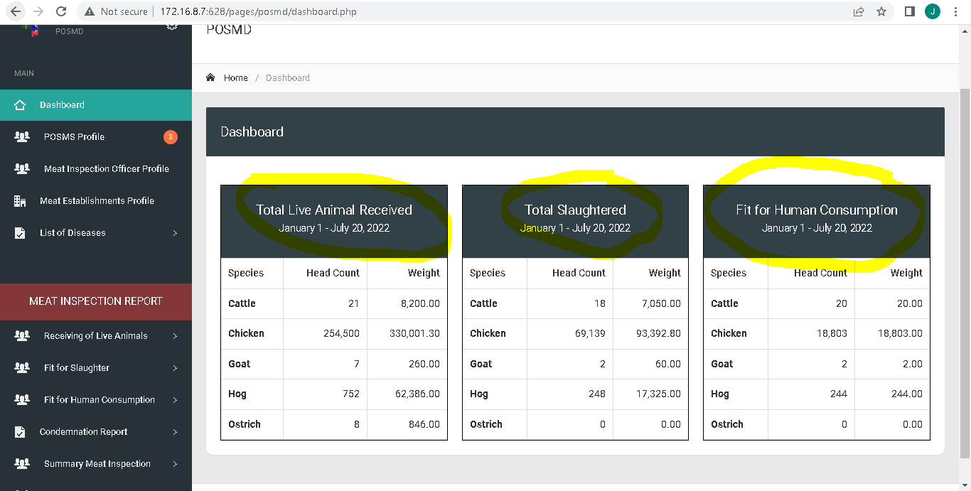

Add column for meat type between total head count and total dressed weight

Reviewed: August 10, 2022(resolved)

Change the label

“Fit for Human Consumption” to

“Total Volume of Meat Fit For Human Consumption”

Reviewed: August 10, 2022(resolved)

Change the label

“Total live animal received” to

“Total Number of Animals Received”

Reviewed: August 10, 2022(resolved)

